Home Page:

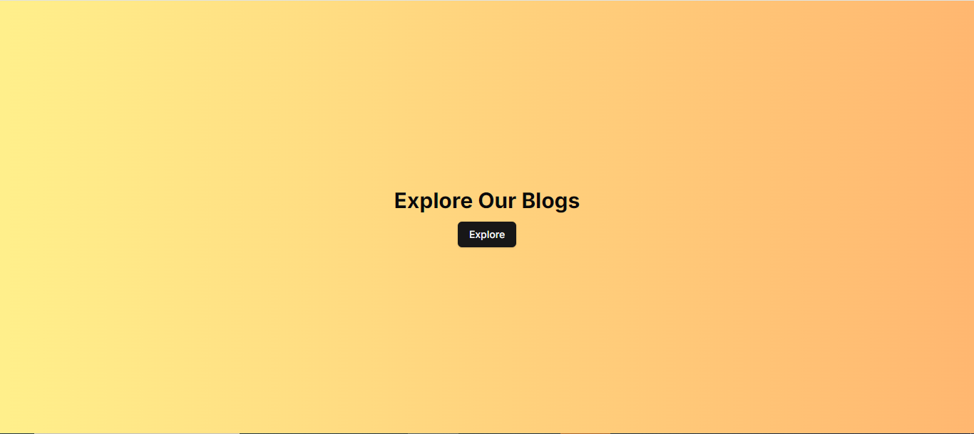

* After clicking explore button the below page will be opened

Blogs Page:

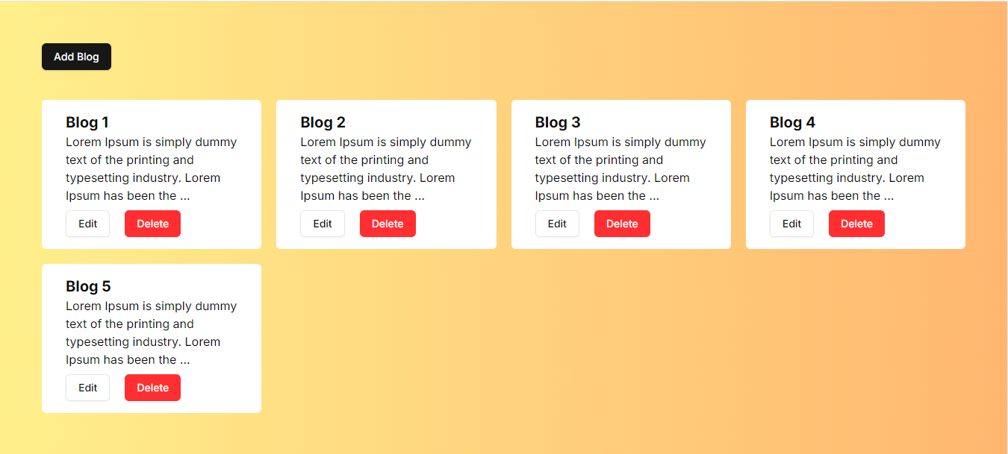

* All the blogs should be coming from database using Laravel and mysql.
* After clicking Add Blog button the below Dialog will be opened

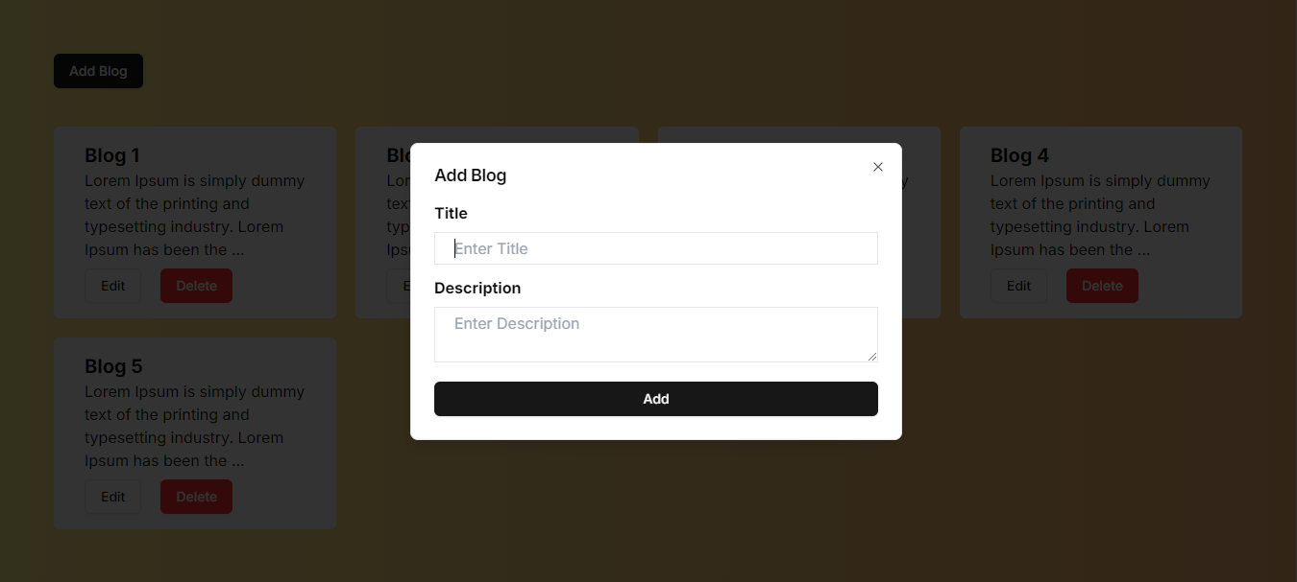

* After clicking on the Edit Button on a blog card, the below Dialogue will be opened with the previous blog data filled.

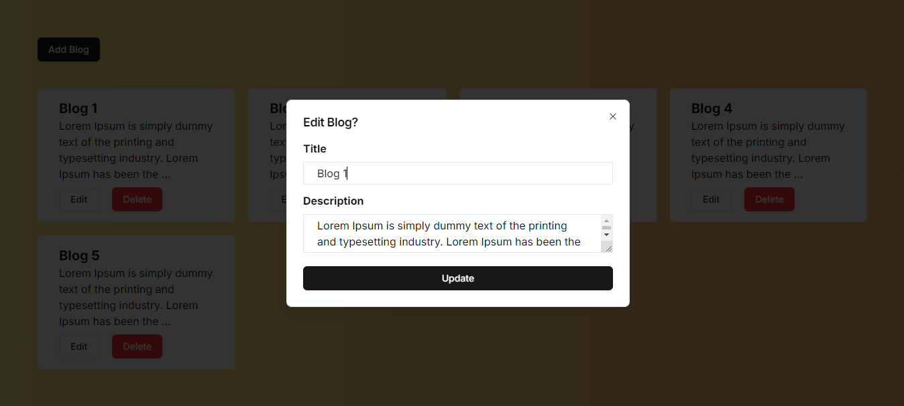

* After clicking on the Delete Button on a blog card, the below prompt should be shown, and on pressing ok, delete the blog otherwise do nothing.

